# The 49th Annual

***Youth***

***Leadership & Diversity***

***Conference***

*A Civitan Youth Seminar Project*

We are making a commitment to a better future by providing a unique experience for young people in an environment that promotes dialogue around diverse views, opening avenues for problem solving, offering time for quiet reflection, laughter, and enjoyable recreation, creating …

“*friendship through understanding”*

July 9 – 14, 2018

Trine University – Angola, Indiana



www.CivitanYLDC.org

***Youth Leadership & Diversity Conference***

We offer an opportunity for high school students to experience a leadership program that is truly unique. For one week during the summer, delegates gather on a college campus and become actively involved in a variety of exercises that will enhance their knowledge of who they are and where they fit into the complexities of an ever-changing society.

During both large and small discussion group sessions, delegates have an opportunity to share their views on a wide variety of topics that are of concern to today’s teens. The format is simple: since each of us comes from a slightly different background, our opinions will differ. That’s understandable. Delegates learn to listen to others, as well as to articulate their own point of view without personally attacking others for holding differing beliefs. Over the years, it has been proven that delegates do not change what they think or value. They do gain insight into other delegates’ thinking and are more able to appreciate differences. For many, it is the first time that they have been given the opportunity to vocalize how they actually feel about the issues being discussed without censure.

It is through the diversity of the delegation that this conference obtains its strength. We do not look at race, creed, color, sex, or ethnic background when selecting delegates. Rather, we truly embrace the differences that each delegate brings, because it is through those differences that delegates learn about themselves and others in this ever shrinking world of ours. It is those special and unique qualities that each delegate possesses that the conference capitalizes on to prove that every person is of special importance to the world as a whole. To be able to look at a person as a valuable asset to society means to look past the stereotypes that may otherwise blind us to the true worth of the individual.

Throughout the week, delegates are grouped and regrouped during a variety of exercises to demonstrate the value of teamwork. In today’s work force, the ability to function as a member of a team is more important that what a person may do or know individually. It is the belief of this conference that every delegate is a leader, and to become more effective and self-assured, certain qualities may need to be enhanced. Through the deliberate structuring of activities to promote teamwork, each delegate has the opportunity to demonstrate his or her individual skills within a safe and non-threatening environment.

There is no better place for the youth of today to experience a program designed to enrich their lives and develop their leadership capabilities than the Youth Leadership & Diversity Conference. It offers, in one short week, what the average individual might take a lifetime to experience.



**Delegate Comments Regarding YLDC**

YLDC was really an amazing opportunity for me, and both my friends and I have seen a difference in myself in the way I act and behave. My confidence has grown, allowing me to meet and make so many new friends and be comfortable in situations I previously would not have been comfortable in. I have more confidence when standing up for people who are bullied and more drive to stand up, because of Kelsey’s seminar on bullying, and Caleb’s heartbreaking story. I’m really more aware of how people are affected by the way others act and how much I can make a difference in a single person’s life because of this conference. Pyper

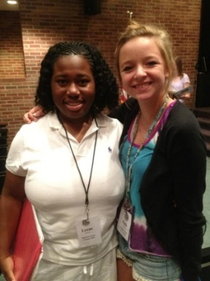Ever since I left, I've been having YLDC withdrawals. I miss everyone, and I wish everybody on earth was as loving, caring, and trust worthy as you guys. Sadly, we don't live in the perfect world. I've noticed the nicer and more helpful I've become, more people try to bring me down and take that away from me. It's sad how people are ashamed to be the one to stand out, and help someone because it's "lame" or it's more fun to make fun of that person. The people at my school would rather brag on what they have, and bring others down because they can't afford it. It's still fairly hard for me to get over the fact that I used to be one of those people. I wish they would be grateful they’re blessed and not bother others. It's like I'm more sensitive to things that didn't bother me before. Now I stay frustrated because of situations dealing with people's actions, and how I can't control them. But on the bright side, I'm doing fine. I've basically been focusing on school and band. I got accepted into MSU's Junior Jazz Program, and I've reached one of my long term goals. I never thought it was possible, but I received a 4.0 GPA. Now I qualify to tutor other people; I can be in NHS and help people improve their grades. I've also been doing community service, and I helped my class win the can food drive at school. I've donated tons of clothes, and I'm going to help my cousin give away food for Christmas. It's funny how one week can change a life forever.

Lexus

I absolutely loved YLDC, and it made a big difference for me. I met a lot of new people who are there for me whenever I need them, like my roommate Alex, from Canada. And I feel that it forms an unbreakable support system for people like me who never really had one, and I wouldn't be able to push myself as much as I do now without her. I want to change more people’s lives. I want to make as big of an impact on people, as YLDC has done for me.

Eillie

I would like to tell you how YLDC change my life. When I left, I thought of how I could change our world. So I thought to myself what can I do to help...... and it hit me. I am going to create a business to help our world; the name is called *We Can Change Our World*. This is about everybody who wants to help clean our world - we will pick up trash, help rebuild someone’s house/paint their house, etc. Then we would move to Detroit and do whatever we can to help. My mom and I are going to make a website for this and then I will go on YouTube and talk about my plan.

Mijai

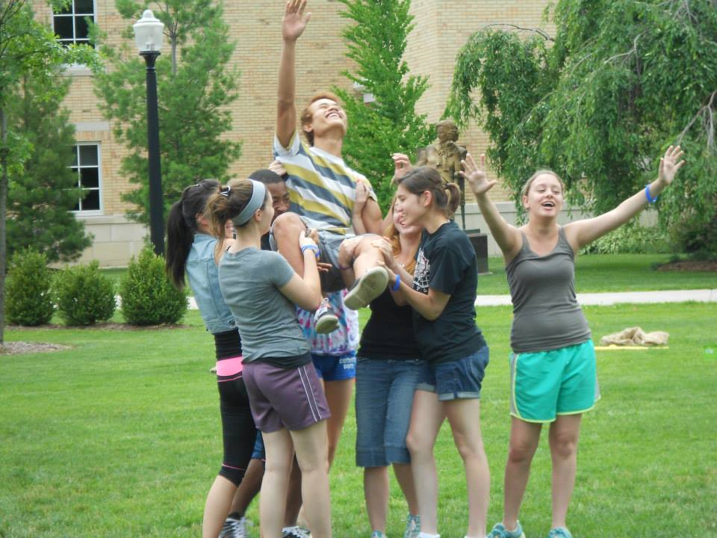I just wanted to say how happy I was to have had the opportunity to be invited to this camp. I have learned so much and made tons of new friends that I still keep in touch with now.  I appreciate every minute you put into making this event possible and I deeply thank all the staff that have shown me nothing but kindness and friendship. The reason I am contacting you at such an early time is because I was looking though my warm fuzzies when I stopped at your comment which said, "Good luck! Be strong! Always remember YLDC." I want to tell you that I won't ever forget YLDC as long as I walk on this earth. The first day that we arrived I remember you telling us that when we left on the last day we would be a different person. At first I didn't believe you, but now I totally see what you meant. You made me look at the world from a different direction, you showed me that the way a person looks shouldn't be a way to judge someone. You taught me how to be accepting to all kinds of people. You showed me that tears don't mean weakness but a sign of strong emotions, and that I shouldn’t be afraid to cry. I thank the staff for showing me how to be a leader and a good role model.

Omar

YLDC has changed my life. I want to help change other’s lives for the better. I don't have any friends at school. I can't keep friends either. But through YLDC I have friends that I talk to on Facebook. I don't feel as alone anymore. I'm bullied. I'm bullied by adults, peers and team mates. I'm bullied and picked on because of my disorders and for who I am. At YLDC I wasn't; you all accepted me for me. I've never been truly accepted for me anywhere outside of my home. It was an amazing feeling. YLDC made me look at myself and figure out who I am, what I stand for, and who I want to be. When you had us write our obituary it really hit me, and when I read it aloud it sunk in. (Thanks for the really long hug afterwards) It changed me forever. Since YLDC, I started NO MORE SHAME. I'm trying to help end the shame about who you are, whether it be race, religion, sexual orientation, gender, social economic class, disabilities, mental illness, or anything that makes you feel ashamed about yourself. Currently I'm trying to get it off the ground. Once I have people who support it, then I can start to change things in the world.

Laura

Thank you so much for the great week that you supplied me with this past summer. It truly did change my life by being surrounded by people with an honest accepting view of the world. The friendships that I made at YLDC will always be cherished. The leadership skills that I acquired have helped me achieve such things as being student body president and captain of both my basketball and football team; I can't help but believe that YLDC had a lot to do with that. Thank you for being who you are and changing my life.

Danny

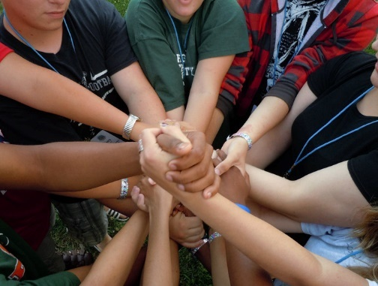I’ve started to see the positive side to practically everything. I look at a group of people with varying talents and I no longer see the “smart” and the “stupid,” I see what I just described, people with varying talents. I no longer see the “able” and the “disabled,” I see people I can learn from, and I see potential friends. I no longer see “gay” and “straight” or “black” and “white.” I see humans and I see diversity amongst them. Since leaving Hillsdale I’ve been volunteering in a class for students with anxiety and depression related issues, and I believe that I have been very accepting and open with them. In contrast, I have changed significantly from the closed-mindedness and aversion to those who were different that I had before YLDC.

Mohamed

***A registration fee of $350 must accompany this application.***

***Return this application no later than June 1st to: Conference Director PO Box 800 Wayne, MI 48184***

***Sponsor Information***

Representative or Contact Person Phone Number

Sponsoring Club or Organization (if applicable) State or Canadian Province

____ Self-sponsored. Attached is a check or Paypal transaction ID: ______________________

# 



2018 Youth Leadership & Diversity Conference

A Civitan Youth Seminar Project

[www.CivitanYLDC.org](http://www.CivitanYLDC.orgcom) [CivitanYLDC@Outlook.com](mailto:CivitanYLDC@Outlook.com)

# APPLICANT INFORMATION … Previous delegates are not eligible for this year’s conference

Any questions regarding the Conference or this application should be directed to the representative listed above. All questions and/or blanks on this application must be completed before it will be considered. Return this application to the above representative on or before the designated date.

If, after applying, you are unable to attend, please contact the above representative immediately.

***Please do not contact Trine University. They have no answers concerning this conference.***

**Type or neatly print all information requested**

Full legal name ___________________________________________________________________________ Male Female

First Middle Last (Circle One)

Name to appear on Name Tag _______________________________________________________ Birthdate _____________________

First (No Silly Slang) Last Month/Date/Year

Home Address _________________________________________________________________________________________________

Number Street City State/Province Postal Code

__________________________________________________________ __________/____________________________________

Delegate’s E-mail Address Delegate’s Cell Phone Number

__________________________________________________________ T-shirt size: ____________

Name of High School

***I will enter the following grade in the fall of 2018: 10 11 12 Circle One***

Parent’s or Guardian’s Name _________________ _____________________________________________________________

Parent’s/Guardian’s Phone (Home) _________/_______________________ (Work) _________/______________________

Area Code Number Area Code Number

Parent’s/Guardian’s Cell Phone #1 _________ /_______________________ #2 _________/______________________

Area Code Number Area Code Number

Person to contract if parent/guardian is unavailable ____________________________________________________________

Relationship __________________________________________ Phone __________/_________________________

Area Code Number

***Please complete the following information so that we will know more about you.***

I participate in the following sports, activities and/or groups: __________________________________________________________________

________________________________________________________________________________________________________________________________________________________________________________________________________________________________________

***Medical Information – NO APPLICANT WILL BE ADMITTED WITHOUT THIS INFORMATION.***

Name of Medical Insurance Plan _______________________________________________ Policy #__________________________

Name of your physician _____________________________________________ Phone _________/________________________

Area Code Number

Are you currently under medical care? _______ If so, for what? _______________________________________________________

We hereby certify that our son/daughter is currently taking the following medication:

Name of Reason Name Reason

_____________________ ___________________________________ _____________________ ___________________________________

_____________________ ___________________________________ _____________________ ___________________________________

Medication can be administered by delegate: Y N Medication should be administered by staff: Y N

He/she is allergic to the following medications: _____________________________________________________________________

Allergies to foods: ____________________________________________________________________________________________

Special health concerns: _______________________________________________________________________________________

***Medical Permission:*** In the event of your inability to contact us, the parents/guardians, in case of emergency medical attention is expedient for our son/daughter, we hereby approve whatever medical attention is necessary and determined by the Hospital Physician or Conference Medical Staff Personnel.

____________________________________________________

Signature of Parent/Guardian

***Waiver:*** I (we), the undersigned parent(s)/guardian(s) of this delegate to the Youth Leadership & Diversity Conference, do hereby release and discharge Civitan International and Trine University, as well as their officers, agents, instructors, and employees from any and all claims, demands, suits, action or causes of actions which I (we) may, can, or shall have by reason of any illness, injury, or accident incurred or suffered by my son or daughter while attending this conference.

________________ ___________________________________________ ____________________________________________

Dated Signature of Parent/Guardian Signature of Parent/Guardian

***Registration is from 3:00 to 4:00 p.m. Plan on arriving during that time period.***

***There are no facilities for meals prior to dinner, so have lunch before arriving.***

If a delegate is driving his/her own automobile, and the car will remain on campus during the conference, please complete the following. Keys will be collected at registration and returned on Saturday morning.

Make: _________________________ Year: _________ Color: ____________ License #: _______________

***Further details will be mailed to each applicant on or about June 15th,***

***providing this application is received by the Conference Director in time.***

It goes without saying…but let’s mention it anyway. Delegates will be expected to keep their rooms neat at all times. There is to be no illegal drugs, tobacco products, or alcohol on campus. Males are only allowed in the lobby area of the female dorm; females are not allowed in the male dorm. No delegate may leave the grounds of the campus. Theft or vandalism is not an acceptable trait for any delegate. Any delegate acting in an irresponsible manner may, at the discretion of the Director, be withdrawn from the Conference. Parent or guardian would then be required to arrange for immediate transportation home. Each delegate will be held responsible for any damage to property caused by that person.

Signature of Applicant Signature of Parent/Guardian

# CURT 2018 Youth Leadership & Diversity Conference

## A Civitan Youth Seminar Project

***Our Week At A Glance***

**MONDAY THURSDAY**

3:00-4:00 Registration & Campus Tour 6:45 Wake-Up Call

4:30 General Session 7:30 Breakfast

5:00 Dinner 8:15 Session: Choices & Consequences

5:45 Floor Meeting with Counselors 10:15 Small Group Discussions

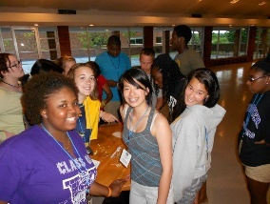 7:00 Orientation Session 11:30 Lunch

10:30 Bed Check 12:30 Session: Focus on Ability

2:00 YLDC Mega Games

**TUESDAY** 5:00 Dinner

6:00 Session: I am Unique; IOPT to Lead

6:45 Wake-Up Call 7:45 Thursday Night Live

7:30 Breakfast 11:00 Bed Check

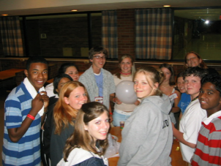 8:15 Session: The Power of One

9:30 Session: Talk to Us

12:00 Lunch **FRIDAY**

12:45 Session: Perspectives in Communication

2:00 Small Group Discussions 6:45 Wake-Up Call

3:30 Recreation Period 7:30 Breakfast

5:00 Dinner 8:30 Session: Sharing Partners

6:00 Session: The Power of Positive 10:00 Session: Friendship is Color Blind

7:15 Session: Teamworlk 11:30 Lunch

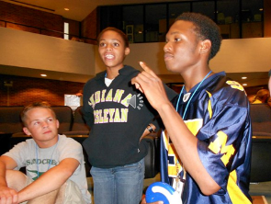 8:30 The Ultimate Challenge 12:30 Session: Global Village

11:00 Bed Check 3:00 Recreation Period

6:30 Banquet

**WEDNESDAY** Variety Show

Dance

6:45 Wake-Up Call 11:00 Bed Check

 7:30 Breakfast

8:15 Session: What Do You Value? **SATURDAY**

10:00 Session: Every Boy/Every Girls

11:30 Lunch 6:45 Wake-Up Call

12:15 Group Pictures 7:30 Breakfast

1:15 Session: Take A Stand 8:15 Check Out

3:00 Recreation Period 9:15 Session: Be The Change

5:00 Dinner 10:45 Session: Reflections

6:00 Small Group Discussion 11:30 Video of the Week

7:30 Cultural Awareness/Personal Visioning 12:00 Departure

11:00 Bed Check

*Program subject to change based on session availability.*

***For Your Information***

* Transportation to and from the conference is the responsibility of the delegate’s family. It is also suggested that car-pooling be used if other delegates are attending from your area. If transportation is provided by the sponsoring club, delegates will be contacted directly.

* There is a $25 materials fee that will need to be paid upon arrival. This is to cover the cost of your souvenir T-shirt, notebook, listing of all delegates attending (along with addresses, phone numbers, and email address), and photographs of the entire delegation as well as the group sent by your sponsor.

* The college does not provide bedding. Pack a pillow, and sheets for a twin size bed. It might get cool at night, so pack a blanket, too.

* Don’t forget to bring enough washcloths and towels for the week.

* The dorm is air conditioned. A light blanket is recommended.

* Do not bring large amounts of money with you. If lost or stolen, it cannot be identified. Snacks & pop are available in the dorm, there is a book store on campus, and you will have the opportunity to order pizza at night. We also offer you the opportunity to keep excess money in an account with us that is available to you whenever you may need it.

* Casual attire such as shorts, jeans, T-shirts, and tank tops are acceptable throughout the week. Short-shorts and other revealing clothing are not acceptable, and, if worn, you will be asked to change.

* There is no pool, basketball or weight training facility available for our use on campus.

* The dorm is WIFI accessible and there is a computer lab on campus enabling you to check your e-mail during free time should you desire.

* Those interested in running can do so every morning before breakfast with the assistance of one of the Staff.

* **Tuesday is designated School Spirit Day**. Plan to bring a T-shirt or sweats bearing the insignia of your school or favorite college.

* **Thursday is Games Day**. Pack something grubby that you don’t mind getting dirty while doing silly games and activities.

* **The Friday night banquet is a dress-up affair**. Guys should bring a suit and tie, or slacks with a dress shirt and tie. Ladies should bring a dress or skirt and blouse.

* Our variety show follows the banquet on Friday night. If you have any talent in song, music, dance, or comedy, you might be interested in performing. Bring whatever you need to assist you, except a piano.

* You may wish to bring a camera. If so, please tape your name to it. Every year there are several cameras left behind and no way to trace the owners.





[www.CivitanYLDC.org](http://www.CivitanYLDC.org)

**PO Box 800 Wayne, MI 48184**

Civitan International, a community service organization, began in 1917 and currently has clubs in 48 countries around the world. Civitan Youth Seminar, an international project for youth, was established in 1969. It evolved into the Youth Leadership & Diversity Conference, A Civitan Youth Seminar Project to meet the changing needs of our society. Civitan YLDC is based in Southeast Michigan and welcomes corporate donations and foundation grants to support this project through Civitan International, a 501(c)3 Organization.

Please make donations written to “Civitan International (YLDC)” and indicate where you’d like your tax letter sent.